Discussion Assignment 3
Below is the analysis of the function $f\left(x\right)=\frac{\left(x^{2}-3x+2)(x-3\right)}{(x+1)(x^{2}-7x+12)}$ step by step:
1. Zeros (Roots):
Zeros of a function are the values of $x$ or which $f\left(x\right)=0$. To find the zeros, we set the numerator equal to zero:
$(x^{2}- 3x + 2)(x - 3) = 0$
We can factor the quadratic in the first part:
$(x - 2)(x - 1)(x - 3) = 0$
Now, we have three factors, and to find the zeros, we set each factor equal to zero:
$x - 2 = 0$ leading to $x = 2$, $x - 1 = 0$ leading to $x = 1$, and $x - 3 = 0$ leading to $x = 3$
Therefore, the zeros of the function are $x = 1$, $x = 2$, and $x = 3$.
2. Asymptotes:
Horizontal Asymptotes: To find horizontal asymptotes, we compare the degrees of the polynomials in the numerator and denominator. In this case, the highest degree term in both the numerator and denominator is $x^{2}$. Therefore, the horizontal asymptote is the ratio of the leading coefficients, which is $y=\frac{1}{1}=1$.
Vertical Asymptotes: They take place where the denominator equals zero but the numerator doesn't, which can be determined by equating the denominator to zero as follows:
$x^{2} - 7x + 12 = 0$
$(x - 3)(x - 4) = 0$
Therefore, the vertical $x = 3$ and $x = 4$.
3. Domain and Range:
The domain of the function $f\left(x\right)=\frac{\left(x^{2}-3x+2)(x-3\right)}{(x+1)(x^{2}-7x+12)}$ has restrictions, it would be comprised of all real numbers except when $x = -$,3, 1 and 4 to avoid division by zero.
The range of the rational function above does not have restrictions on the numerator, it can take all real numbers.
Graphing the Function:
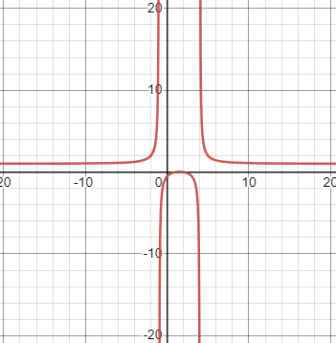
5. Value of the Function at $x = 3$:
At $x = 3$, we need to calculate the value of the function:
$f\left(3\right)=\frac{\left(3^{2}-3(3)+2)(3-3\right)}{(3+1)(3^{2}-7(3)+12)}=\frac{(9-9+2)(0)}{(4)(9-21+12)}=\frac{(2)(0)}{(4)(0)}=\frac{0}{0}$
Since the $f(3)$ of the function above leads to because it results in an indeterminate form $\left(\frac{0}{0}\right)$, we can conclude that it is undefined at$x = 3$due to the common factor of $x – 3$ found in both the numerator and denominator.

